# Homework 4 – Active Directory and Group Policy Objects

* (**Task 1**) Show in a screenshot that the three domain users (sqluser1, sqluser2, sqluser3) are created in **SQLUsers** OU. Also show in a screenshot that **sqlgroup** is created in the **Groups** OU.

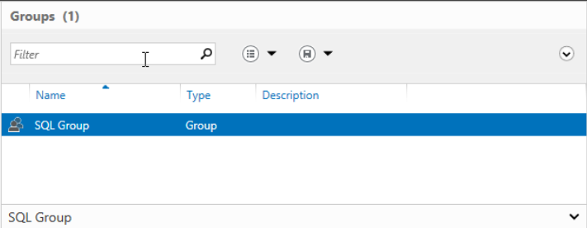

* (**Task 2**) Go to sqluser1 properties and show in a screenshot that sqluser1 is a member of **Domain Admins** and **sqlgroup**.

* (**Task 3**) Run the following query on SQL Server and show in a screenshot that you indeed logged-on with sqluser1.

* (**Task 4**) Logon to SQL Server. Create a login “**Cardinal1**”. Select **SQL Server authentication**. Enter the password “1234567”, and show in a screenshot that the login cannot be created. Explain why?

The password failed the complexity policy.

* (**Task 5**) Create a login “**Cardinal1**”. Select **SQL Server authentication**. Enter the password “1234567” and show in a screenshot that the login is created. Explain why this was possible. Explain also the relationship between the GPO and the SQL Server password policy.

The password policy for complexity was disabled and allowed for more flexibility in password creation including the designated test password. GPO set the rules that the SQL Server password policy must enforce. This is seen by the enabling and disabling of the complexity rule.

* (**Task 6**) Create a new AD account using the command **New-ADUser** explained on pp 12-13. Show in a screenshot that the account is indeed created (example below). Also, attach a screenshot that displays the PowerShell execution.

 